 ^{UCSD Core Bio Services}

CELL STORAGE AGREEMENT
BETWEEN THE REGENTS OF THE UNIVERSITY OF CALIFORNIA
AND

____________________________________

I. GENERAL DESCRIPTION

The University of California ("UNIVERSITY") at San Diego ("UCSD") Core Bio Services (CBS) stores cells and other biological samples in large liquid nitrogen freezers for a variety of companies and scientists or their representatives (“Depositors”), including UCSD and non-UCSD investigators and companies. Storage boxes hold 81 vials in a 9 x 9 grid. The boxes are kept in racks of twelve boxes. Depositors may "rent" by the box or by the rack. The advantage of renting an entire rack is that all the boxes will be in one location.

CBS cannot accept for storage any organism that is on the US select agents list. Depositors must certify in writing that no such organism or its DNA is contained in their boxes (See Appendix A).

CBS has its own inventory system to track the racks and boxes of each Depositor in the CBS freezers. When cells are placed in the freezer, CBS personnel provide the Depositor with the location of each vial stored on that day. It is the Depositor's responsibility to maintain records of where cells are located within their boxes. Only boxes provided by CBS may be used in CBS freezers.

II. STORAGE SERVICES

Below are the options for the type of storage to be provided by CBS to __________________________________ (hereinafter referred to as "Depositor"). Please mark your choice for the options given below.

1. Cells will be delivered to CBS ( indicate choices )

___________ in labeled vials for CBS to process using slow controlled freezing.
___________ on dry ice, sealed in vials.

2. Space will be rented by ( indicate one choice )
_______ the box or ________ the rack.

3. CBS personnel will ( indicate one choice )
_______ place _________ or supervise the placement of the frozen vials in the Depositor's boxes in the liquid-nitrogen freezer. Depositor is responsible for knowing the content of the boxes in CBS storage. CBS is responsible for tracking location of Depositor’s racks and boxes in the freezer(s). CBS will maintain boxes at liquid nitrogen temperature until CBS is requested to remove boxes by the Depositor or an authorized representative of the Depositor (ARD). CBS personnel observe the temperature read out of each freezer daily and maintain appropriate liquid nitrogen levels. CBS will notify Depositor or ARD if a freezer failure occurs which causes the boxes to be warmed to a temperature in excess of -40ºC. Depositor acknowledges CBS is subject to the available local supply of liquid nitrogen subject to market conditions, as well as an electrical supply on the San Diego County grid.
CBS will make every effort to protect the freezers, but shall not have any obligation or liability for damage occurring in the event of a natural disaster, a regional liquid nitrogen shortage or interruption of electrical service to CBS.

4. Contents of the boxes remain the property of Depositor. CBS will only permit Depositor or ARD access to Depositor’s boxes.

5. Upon request from the depositor, CBS personnel will remove or supervise removal of vials or boxes and immediately give them to Depositor or ARD. Removals must be scheduled with at least 24 hours advanced notice during business hours.

6. CBS will only accept vials from or release vials to Depositor or ARD. CBS will maintain records of each deposit and removal signed by both Depositor (or ARD) and a member of the CBS.

Authorization will be by: (indicate all choices that apply)
________ prior designation of up to four pickup representatives.
________ CBS will call designated contacts to verify that the request is genuine.
________ CBS will require the representative to present picture identification.
________ CBS will fill out and sign the form presented by Depositor.

The representatives and contacts for authorization are to be listed at the end of this agreement.

III. GENERAL PROVISIONS

1. The term of this agreement shall be from ___________________, _____ through ___________________, _______.

Notwithstanding any other provision to the contrary, this Agreement may be terminated without cause at any time by either party upon thirty (30) days' prior written notice.

- The Depositor will be charged for storage, retention and removal according to a rate schedule provided to Depositor at the time of the agreement. These rates may be changed by the CBS without notice. A purchase order must be presented to the CBS business office on or before the day the first cells are stored. Depositors purchase order may cover storage for a year or for six months. Storage fees may be billed monthly, every 6 months or annually until the total monetary value of the PO is reached. Depositor will be billed (indicate one choice)
____________ monthly
____________ six monthly
____________ annually

When an account is two months in arrears, CBS will have the right to remove Depositor's cells and dispose of them. CBS will make a good faith effort to contact the depositor at the last known address by email and by certified mail of the payment due. If full payment for cell storage charges is not made within two months after such notice was sent to Depositor, CBS shall have the right to remove Depositor's cells and dispose of them with no further notice.

Depositor must bring billing discrepancies or errors to the attention of CBS within ninety (90) days or Depositor waives the right to any refund or adjustment.

3. Each party agrees to self-insure or maintain programs of insurance with respect to its own activities under this Agreement as follows:

(1) Comprehensive or Commercial Form General Liability Insurance (contractual liability included) with a limit of one million dollars ($1,000,000) per occurrence. However, if such insurance is written on a claims-made form, it shall continue for three years following termination of this Agreement. The insurance shall have a retroactive date of placement prior to or coinciding with the effective date of this Agreement.

(2) Workers' Compensation and Employer's Liability Insurance in a form and amount covering each party's own full liability as required by law under the Workers' Compensation Insurance and Safety Act of the State of California and other applicable statutes as amended from time to time.

It should be expressly understood, however, that the coverages required under this section shall not in any way limit the liability of the parties.

The coverages referred to under (1) above shall be endorsed to include the other party as an insured. Such a provision, however, shall only apply in proportion to and to the extent of the negligent acts or omissions of that party, its officers, agents, and/or employees. Depositor, by execution of this Agreement, certifies that it has insurance in compliance with all the above requirements. UCSD, by execution of this Agreement, certifies that the University of California insures its liability and property exposures through a self-insured program with a self-insured retention of $5,000,000 per occurrence. Coverage is extended to UCSD employees while acting within the course and scope of their employment. No separate certificates of insurance will be forthcoming.

4. Depositor shall defend, indemnify and hold UNIVERSITY, its officers, employees and agents harmless from and against any and all liability, loss, expense (including reasonable attorneys' fees), or claims for injury or damages arising out of the performance of this Agreement but only in proportion to and to the extent such liability, loss, expense, attorneys' fees, or claims for injury or damages are caused by or result from the negligent or intentional acts or omissions of Depositor, its officers, employees, or agents.

UNIVERSITY shall defend, indemnify and hold Depositor, its officers, employees and agents harmless from and against any and all liability, loss, expense (including reasonable attorneys' fees), or claims for injury or damages arising out of the performance of this Agreement but only in proportion to and to the extent such liability, loss, expense, attorneys' fees, or claims for injury or damages are caused by or result from the negligent or intentional acts or omissions of UNIVERSITY, its officers, employees, or agents.

5. In the event of any dispute arising between the parties concerning the interpretation or enforcement of the provisions of this Agreement, the parties agree to first attempt in good faith to resolve the dispute between themselves. If the parties are unable to resolve the dispute within thirty (30) days, then all matters in controversy shall be submitted to binding arbitration pursuant to California Code of Civil Procedure section 1280, et. seq. using the offices of the American Arbitration Association. Arbitration shall be initiated by either party making a written demand for arbitration on the other party and to the American Arbitration Association. The parties agree that either party to an arbitration may seek judicial review by way of a petition to the court to confirm, correct or vacate an arbitration award pursuant to the provisions of Code of Civil Procedure sections 1285 et. seq. and 1294 et. seq. The parties have executed this Agreement as indicated below.

6. Interruption of Services
Any of the parties shall be excused from any delay or failure in performance hereunder caused by reason of any occurrence or contingency beyond its reasonable control, including, but not limited to, acts of God, acts of war, fire, insurrection, labor disputes, riots, earthquakes, or other acts of nature. The obligations and rights of the parties so excused shall be extended on a day-to-day basis for the time period equal to the period of such excusable interruption. In the event the interruption of the excused party's obligations continues for a period in excess of thirty (30) days, the other party shall have the right to terminate this Agreement upon ten (10) days prior written notice to the excused party.

7. Assumption of the Risks
Depositor understands that the storage services provided by CBS carries with it certain inherent risks that cannot be eliminated regardless of the care taken by CBS to avoid damage or destruction of the stored materials. Depositor uses CBS services at its own risk.

8. Counterparts
This Agreement may be executed in separate counterparts, none of which need contain the signatures of all parties, each of which shall be deemed to be an original, and all of which taken together constitute one and the same instrument. Telecopied or scanned signatures will be deemed to have the same effect as an original.

THE REGENTS OF THE UNIVERSITY OF CALIFORNIA,
on behalf of UCSD Health Sciences

By:_____________________________________________ _____________
Rina Davison Date
Assistant Vice Chancellor
UC San Diego Health Sciences Administration

____________________________________________ ______________
Name: Date
Title:
Company:
Address:
Phone:

Authorization may be made by these individuals
_________________________________________________________________________
(name) (phone)
_________________________________________________________________________
(name) (phone)
_________________________________________________________________________
(name) (phone)
_________________________________________________________________________
(name) (phone)

Representatives for pick up:

_________________________________________________________________________
(name)
_________________________________________________________________________
(name)
_________________________________________________________________________
(name)
_________________________________________________________________________
(name)
Select Agent List
Appendix A

Core Bio Services cannot store any agent that is on this list, their DNA(>66% of the genome) or toxins. Please certify that you have not deposited any of these by signing below.
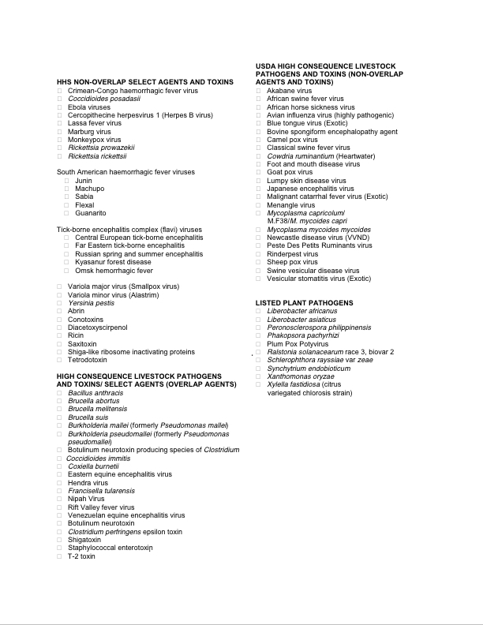

The current list is on CDC's web site, http://www.cdc.gov/od/sap/docs/salist.pdf.

I certify that I am not storing any of these agents in the Core Bio Services Freezers.

Depositor:_____________________________________ Date: _______________________

