Select Agent List
Appendix A

Core Bio Services cannot store any agent that is on this list, their DNA(>66% of the genome) or toxins. Please certify that you have not deposited any of these by signing below.
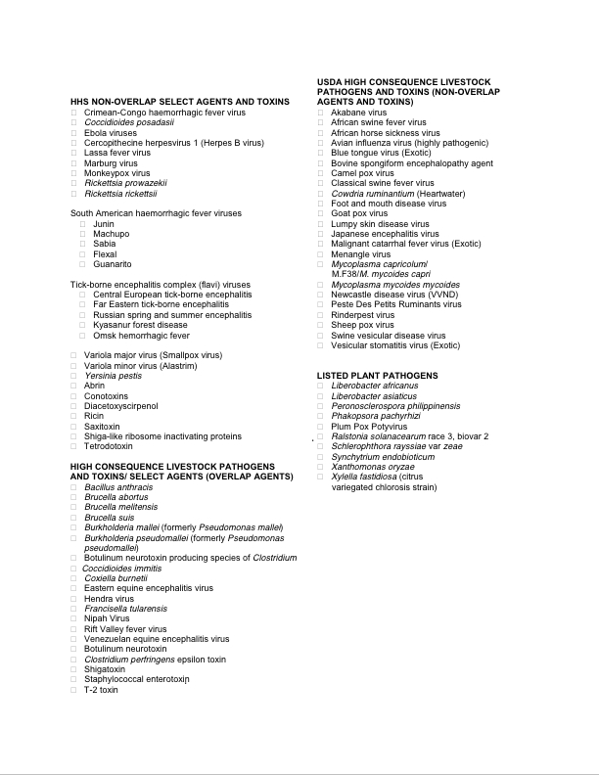
I certify that I have not stored any of these agents in the Core BioService Freezers.

Depositor:_____________________________________ Date: _______________________

